Welcome

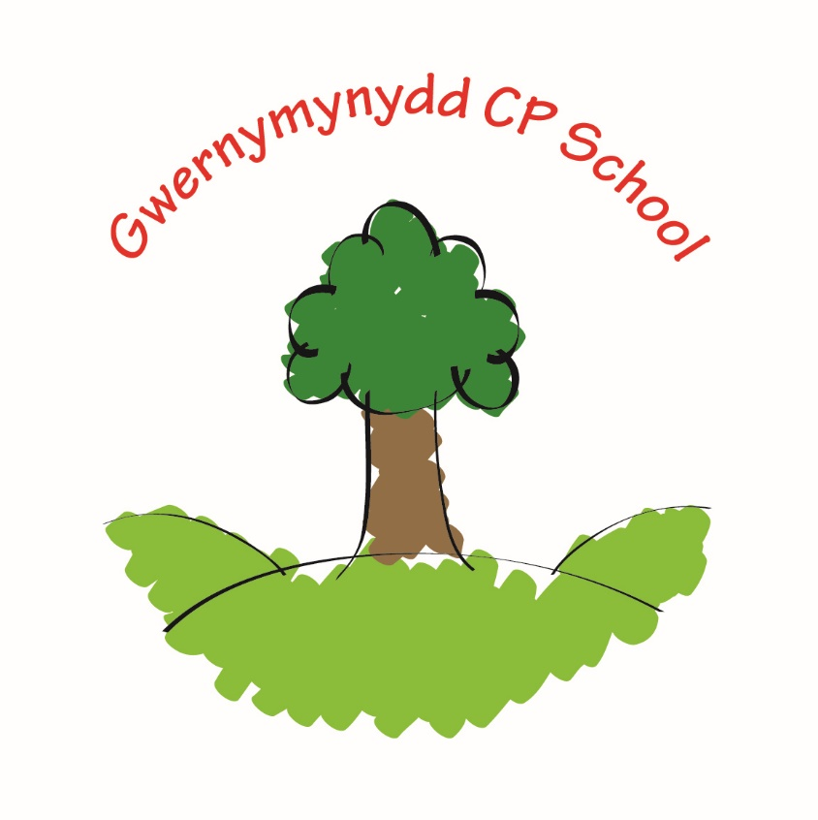

Croeso

Nursery Induction Information
September 2023

Staff

All our staff are qualified teachers or classroom assistants. In our foundation phase classes we have a good ratio of adults to children so that your child receives as much individual attention as possible. All staff are given the opportunity to attend a variety of courses organised by the school, local authority, colleges and universities.

- Head Teacher - Mrs L Ankers

- Deputy Head Teacher - Mr D Johnson

- Class 1 (Nur, Rec, Year 1) - Miss H Smith

- Class 2 (Year 2, 3 and 4) - Miss E Hooson

- Class 3 (Year 5 and 6) - Mr Johnson/Mr J Southall

- Learning Support Assistants - Mrs L Hughes, Miss A Jones,
Mrs J Albrighton, Mrs C Wright, ANO

Additional Educational Needs

- Teacher/Co-ordinator - Mrs M Newton

- ELSA/Catch up Assistant - Mrs L Hughes

- Talkboost Assistant - Miss A Jones

- Secretary - Miss N Telfer

- Caretaker - Mr R Smith

- Cleaner - Mrs J Homersley

- Breakfast club staff - Jane/Carol

- After School Club - Jane, Carol, Beth

The Nursery Day

- Arrival, 8.40 am
- Registration, 8.50 am.
- Home time, 11.30 am.

During the day your child will be learning through first hand experiences. We plan and provide activities which enable valuable learning opportunities throughout the day in a relaxed and happy atmosphere. During your child’s early years at Gwernymynydd CP his/her curriculum will encompass the ‘Curriculum for Wales’ framework as outlined in the Welsh Office document of that name and we also use a document written for non-maintained nursery settings called ‘Enabling Learners’. This document has a high focus on learning experiences before children are working at the CfW levels.

This document focuses on the key principles that are essential for holistic and meaningful learning for all learners during the first few years of school. Fundamental to this are three ‘enablers’, identified in this guidance as:

- enabling adults
- engaging experiences
- effective environments

These enablers are integral to teaching and learning across Curriculum for Wales. Particular focus is given to the following key features, which are essential for this period of learning:

- play and play-based learning
- being outdoors
- observation
- authentic and purposeful learning

When designing our curriculum offer, staff knowledge and understanding of child development is essential. The focus of teaching and learning includes the traditional areas of child development, following five developmental pathways:

- belonging
- communication
- exploration
- physical development
- well-being

The pathways are child-centred and are interdependent, having equal value in supporting overall development and progress. By following a bespoke curriculum for our pupils we ensure progression from the pathways through to Progression step 1 of CfW for all learners.

There are six taught ‘areas of learning and experience’ which are delivered through a variety of learning contexts. Here are just some of the experiences that your child will experience:

- Role play.
- Small world play.
- Dough and malleable play.
- Sand and water play.
- Information Technology.
- Creative development.
- Outdoor play.
- Physical development.
- Welsh.
- Personal, Social, Moral and Cultural Education/Religious Education.
- Music.
Please click on the links below to find out more information.
This first link takes you to a guide for children and families: https://hwb.gov.wales/api/storage/44b74558-5d89-4a5b-bf54-32bd6dcad1c0/a-new-curriculum-in-wales-a-guide-for-children-young-people-and-families.pdf
This link takes you to a short video animation to explain the main changes. https://www.youtube.com/watch?v=Am1wg46OsCE
We are really excited about the possibilities the new curriculum offers and across the Hafod federation we have designed logos to represent each of the 4 purposes. Each class also works on understanding what each purpose means and have changed the wording to ‘child friendly speak’ so that we all understand what it means to develop as the 4 purposes.

Ambitious, capable learners who:  • set themselves high standards and seek and enjoy challenge;  • are building up a body of knowledge and have the skills to connect and apply that knowledge in different contexts;  • are questioning and enjoy solving problems;  • can communicate effectively in different forms and settings, using both Welsh and English;  • can explain the ideas and concepts they are learning about;  • can use number effectively in different contexts;  • understand how to interpret data and apply mathematical concepts;  • use digital technologies creatively to communicate, find and analyse information;  • undertake research and evaluate critically what they find and are ready to learn throughout their lives.  Ambitious and capable | Enterprising, creative contributors who:  • connect and apply their knowledge and skills to create ideas and products;  • think creatively to reframe and solve problems;  • identify and grasp opportunities;  • take measured risks;  • lead and play different roles in teams effectively and responsibly;  • express ideas and emotions through different media;  • give of their energy and skills so that other people will benefit and are ready to play a full part in life and work.  Enterprising and creative
Healthy, confident individuals who:  • have secure values and are establishing their spiritual and  ethical beliefs;  • are building their mental and emotional well-being by  developing confidence, resilience and empathy;  • apply knowledge about the impact of diet and exercise on  physical and mental health in their daily lives;  • know how to find the information and support to keep safe  and take part in physical activity;  • take measured decisions about lifestyle and manage risk;  • have the confidence to participate in performance;  • form positive relationships based upon trust and mutual  respect -face and overcome challenge;  • have the skills and knowledge to manage everyday life as  independently as they can;  • and are ready to lead fulfilling lives as valued members of  Healthy and confident  society. | Ethical, informed citizens who:  • find, evaluate and use evidence in forming views;  • engage with contemporary issues based upon their knowledge and values;  • understand and exercise their human and democratic responsibilities and rights;  • understand and consider the impact of their actions when making choices and acting;  • are knowledgeable about their culture, community, society and the world, now and in the past;  • respect the needs and rights of others, as a member of a diverse society;  • show their commitment to the sustainability of the planet and are ready to be citizens of Wales and the world.  Ethical and informed

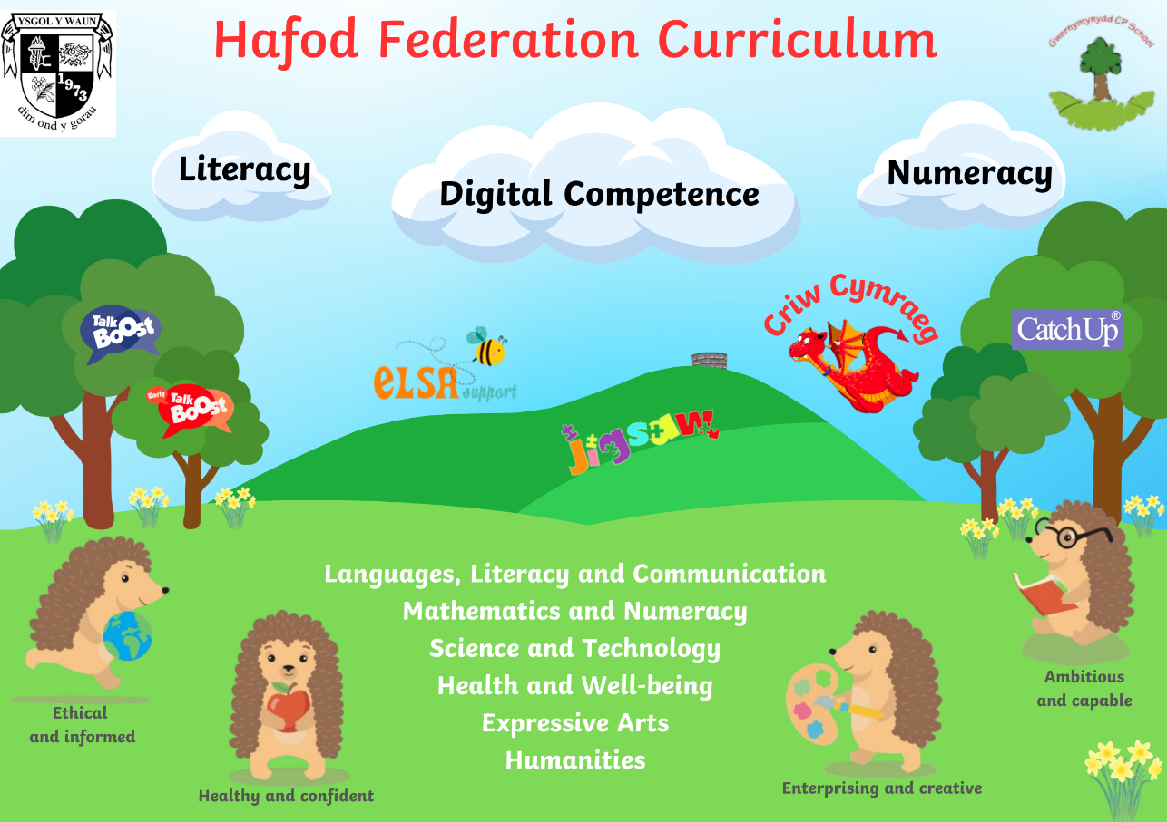

The First Few Days

Our policy is to provide the children in our care with a pleasant and enjoyable introduction to school. The first few weeks will be spent with the children getting familiar with their new surroundings, staff and routines. Teachers and support staff will be making observations as to how your child carries out certain activities and planning for the next day based on what your child has enjoyed that day.

A staff member comes to the main visitor gate at 8.40 am and children are invited to walk down to school by themselves. If you would prefer to walk to the door with your child, Nursery parents can walk to the door to pass on any information and check they are settled. Please can we ask for this from 8.45 am to allow most of the school children through first. Collection is at 11.30am from the main gates (where you drop off) where children will be passed onto you or any private childcare provider.

If your child is upset on entry into school, don’t worry! That is not unusual. The best way to deal with it is:

- To reassure them.
- Leave them in the care of the class teacher or learning support assistant, part of their job is to comfort an unsettled child.
- Telephone the school later in the morning if you are worried, we are always happy to let you know how your child has settled.

Staff are available to speak to at the end of each day if you have any problems or concerns – please do come to see us if you or your child have any worries, we want to act on them before they develop further.

Useful Information

- Start of the Day – Nursery children will come in through the main door straight into their cloakroom with their peers and staff. We encourage children to hang their own belongings up and put their book bag, water bottle and snack in the box in their classroom. If you arrive after registration, you will need to enter the school through the main door at the secretary’s office.
- Home time – Nursery children are to be collected from the main gate at 11.30am. Each child is released only to their parents or pre-arranged adult representative. If you know you will be unable to collect your child personally we ask for a phone call/ email explaining the person of your choice to collect your child from school. Please try to be on time as children do get upset when parents are late.
- Wraparound Care – Sunbeams Playgroup, based at Ysgol Y Waun offer wraparound care from 11.30am until 3.00pm. Rachel who runs the club does pick-ups/drop offs at Gwernymynydd if you choose to use this facility. Children need to bring a packed lunch.
- School nurse – Mrs E Speed visits us on a regular basis. For Nursery aged children referrals are arranged by your Health Visitor, however, if you would like to consult her on anything please let us know.
- Reading sounds – We teach the sounds using the Jolly Phonics programme. We will send information home with the sounds and actions in September but in the meantime if you are starting to talk about sounds please can we ask you teach them softly as ‘ssss’ rather than a hard ‘S’ or the name ‘ess’. I am sure you will find clips on Youtube if you want to check.
- Breakfast initiative – Gwernymynydd CP offer the WG free Breakfast Initiative from 8.20 – 8.50am. We also offer childcare for anyone needing a little longer, children can arrive from 7.45am at a cost of £1.50 per child, then from 8.20am until 8.45am it is free of charge (latest children can attend is 8.30am). The children are provided with a healthy breakfast and then supervised until school begins. A booking form is on Weduc where you can book/pay in advance.
- Snack – Children are encouraged to bring fruit for snack. This can be a whole piece or cut up in a plastic tub. Please can we ask that grapes are cut lengthways for safety as they can be a choking hazard if kept whole. Children will also have a drink of milk or water mid-morning. Please ensure you inform us of any known allergies or dietary requirements.
- After School Club – Gwernymynydd CP offer childcare from 3.00pm until 5.00pm, they are based in the school hall. The price is £4.00 up until 4pm and £8.00 up to 5pm. A booking form is available to all parents via Weduc each week.
- Accidents – If your child is hurt during the school day he/she will be cared for by staff and we will contact you if we feel it necessary.
- Toileting – We do have two small toilets available to our youngest children and in the first few weeks we do tend to do toilet visits on mass to ensure that they get into a routine of going in school. It would be a great help to us if you could send spare underwear to school incase they do have an accident, often it is that they are too busy playing and forget to go.
- Illness – If your child becomes unwell, we make every effort to contact you. Please make sure you keep your contact numbers up to date to make our task easier. It is important you keep your child at home for at least 48 hours after any bug, this helps to minimise the risk of other children and staff becoming ill.
- Reading – We encourage children to develop early reading skills right from the start of Nursery and Reception. Previously children have used book bags, however we now have plastic reading folders so the bag in not necessary. Please return book folders every day as letters/correspondence are put in them. As new sounds are introduced we will share these with you. Please support your child in learning to read and write their name and recognise the letters from their name in the environment, e.g on road signs, house names, posters etc.
- Uniform – Your child will need a school uniform. Our uniform is grey skirt/dress or trousers, a red polo t-shirt and navy cardigan or sweatshirt. Some children have these with the school logo on but we are happy for you to buy plain ones. On PE and outdoor learning days children are to come to school in black jogging bottoms and a white PE t-shirt with plain black zip up jacket. These days will be confirmed in September. Please remember to label EVERYTHING and show your child where they can find their name on each item. Spare clothes are kept in school in case of accidents of any kind but we would appreciate it if you kept a spare set of underwear in their bag. Children do always wear aprons for gluing, painting and messy play but accidents do happen! If your child does come home with less than perfect clothing it shows they’ll have had a good time!
- What not to bring to school – Please do not encourage your child to bring toys to school. When toys are lost or broken, it always causes upset. Toys are safer at home.
- Medication - If your child is taking prescribed medication, you will need to complete a medication form, please ask in the office for this. If your child suffers from asthma, please can we ask for a spare inhaler for use in school? The inhaler and spacer should be given to the class teacher with instructions, the child’s name and date of birth written clearly on the inhaler and spacer. This will be stored where all staff have access to it.
- A special reminder – When coming to school in the mornings or collecting at the end of the session, please park responsibly so not to block driveways.

- Our biggest aim is for your child to have an enriching, happy and pleasant time in Gwernymynydd CP. To do this we need to work as a team.

